REGAIN WHAT YOU HAVE LOSS

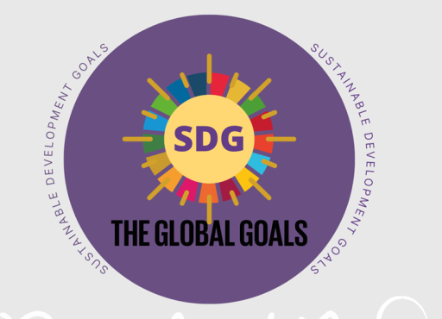

1.INTRODUCTON:

This project is about developing games that will help us to achieve SDG goals

2.Theme OF THE PROJECT:

The main theme/idea is to develop games that are not Only entertaining & fun but also educational and knowledgeable.

3.problem statements:

The world is facing serious problems on poverty, getting quality education, and inequality, gender equlity , life below water,

Life on land , climate action , peace ,justice and strong institutions, clean water and sanitation.

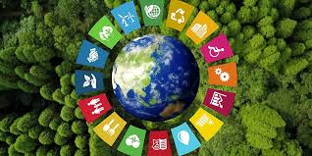

Existing solutions and limitations

1. No poverty:over 10% of the world population,still lives in extreme poverty today.”Rural development” was one of the schemes which were brought in yet poverty is one of the major issue today.

According to statistics, 2/3rd of population live in poverty and majority of water bodies are contaminated...and the problems go on

2. Zero hunger:tackling hunger on the frontline of emergencies is critical but we also need long lasting solitions which is why “Food assistance” was brought,who provide money for food we can change it buy providing employment to people.

3. Quality education:the flagship government scheme,”sarva shiksha abhiyan” is aimed at achieving universal quality education,we can show importance of education though games.

4. Good health and well being :the government of india brought “national health mission”prioritises national wellbeing and is leading change in this area,we can bring awareness around the world.

5. Gender equality:ending violence against women is a key national priority,which resonates with the SDG targets ,”Beti Bachao Beti Padhao”initiative aims at equal opportunity and education for girls,we show the importance of equality in society.

6. Clean water and sanitation:the critical importance of sanitation,hygiene and adequate access to clean water for preventing from diseases,which is why”Water action decade”has been for the challenges of water scarcity.

7. Affordable and clean energy:the environment provides a series of renewable and non-renewable energy sources like solar,wind,hydro power etc.helps in the decrease of energy.

8. Decent work and economy growth: environment plays an important role in supporting economic activities, we will help in providing better employment opportunities.

9. tion of employment and income,it helps in promoting new Industry innovation and infrastructure: it helps in generatechnologies ,we can help others to invent through their ideas.

10. Reduced inequality:reducing inequalities among age,sex,disability,race,ethnicity,origin etc.we came help in bringing awareness in these categories.

11. Sustainable cities and communities:building urban resilience is crucial to avoid human,social and economic loss by improving sustainability to prevent disaster risk and climate change.

12. Responsible consumption and production: it is about decoupling economic growth for them neat and clean

13. Life on land:land and forest are the foundation of earth’s surface and to intergate ecosyenvironmental degradation for providing sustainable lifestyle,we can also help in it.

14. Climate action:it is effecting every country on every continent,”Paris agreement” was brought in action but we can help in providing and educating about the cause of climate changes.

15. Life below water:the water covers 70% of the surface of planet ,however most of the coastal waters are polluted we have to make sure to keep stem and biodivercity values into local planning,we can help people to learn the importance of the life on land.

16. Peace justice and strong institutions:conflict,insecurity,weak institutions access to justice and a great threat to sustainable development,we have to help people find the right judgement for the right decision making.

17. Partnerships for the goals:we can join with different kind of companies to learn how exactly work on thing which will help us in new learning experience and they can help us in development of the community.

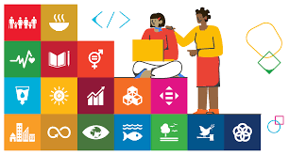

Proposed solution:

* The project is about the SDG goals. As we know majority of people these days don't follow rules which are leading to major problems the world is facing today
* So we are developing a game that would be of some help to solve these problems, that reminds us to follow rules
* Our main idea is to develop or suggest scary games that instil fear in children's minds and remind them about the consequences of not following these rules

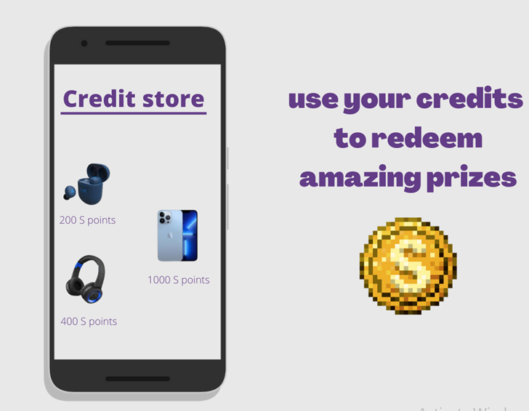

* And also the games that teach us values and morals like the importance of farming , clean water, roads (SDG 6), healthy and fit lifestyles(SDG 3), and in more broader sense the importance of peace and justice( SDG 16)
* The players of the game will be awarded with coins at each level which is converted to real money ( only in No poverty SDG ). This money will be donated to orphanages.

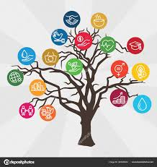

* As everything has it's own positive and negative sides , technology too has it's own negative impact on today's generation. Youth are addicted to social media and games a lot more than they should. But if we can focus on the positive side of technology and gaming, we can develop games that will educate our kids and youth along with the fun and and exciting parts
* So on a concluding note, the main theme/idea is to develop games that are not fun but are also educational and knowledgeable.

Done by :

T.Dharma Nithin

21R11A6692

CSE-AIML

K. Lakshmi Priya

21R11A6673

CSE-AIML-B

K.Eesha

21R11A6670

Cse –aiml

Sugresh

21R11A6653

Cse-aiml